EMERGENCY GEAR, by Sylvia Seaberg
PACIFIC OFFSHORE ACADEMY, 19 OCTOBER 2013

It was 1998 and I was sailing my first Pacific Cup aboard an Olson 34. It was very early in the morning, about 2:00 a.m. (isn’t it always?), the skipper, Brian, was driving and I was actively trimming the spinnaker through a squall. Just about the time that Brian complained about both looked at each other and exclaimed “What are you doing?!?” A second later he realized what had happened and told me the boat had lost its rudder. I freaked out. I knew we had an emergency rudder but since I hadn’t practiced deploying it I didn’t have a clue what to do. Brian got the emergency rudder, slipped it into its cassette, and things eventually got sorted out. The other two crew members assisted in deploying the emergency rudder, but I fear I was very little help.
I realize this is a somewhat unadventurous story, it doesn’t involve any rescues, nobody’s life was in danger, and the boat continued to Hawaii with only very slight moments of drama (the greatest of which was that our last dessert took a tumble on the cabin sole). But it’s a story that I hope makes two important points. The first is that although skippers and boat managers seem to spend an inordinate amount of time and stress on our emergency gear, we should be spending at least that amount, if not more, on our boat’s original equipment. The second is that it is not enough to just have your emergency gear on board, but that every crew member should know where the gear is and the procedures for deploying the gear. And that requires practice; usually a lot of practice. Skippers AND crew should ensure that everyone on the boat shares in the responsibility for the boat, themselves and others.
The Dichotomy
We are required to have emergency gear, yet we should do everything in our power to prevent our having to use this gear. Before obsessing about emergency gear, every participating skipper should ask the questions, when was the last time we inspected, updated, or replaced our rigging? Pulled the mast? Hauled the boat and inspected the rudder? Every time I/we have hauled a boat to inspect the rudder we have uncovered a potential problem. In the worst case it was a waterlogged rudder which necessitated a replacement, in one of the best cases it was worn rudder bearings which would have made for a challenging two thousand mile trip. There are numerous articles on the Pacific Cup website that have to do with assessing rigging, mast, hull, rudder and other key items that keep your boat sailing smoothly. Read them at the Pacific Cup Knowledge Base and pay attention to your boat.

Emergency Gear
Now that you have inspected and are confident about your hull, rigging, mast and rudder we can talk about emergency gear. In this article I will discuss some of the changes to the Category 1 Offshore Special Regulations and 2014 Pacific Cup Equipment List…
- EPIRBs
- Storm and Heavy Weather Sails
- Fire Plan
- Personal Equipment

…and then touch upon some of the key emergency gear that is required for the Pacific Cup.
- Emergency Steering
- Crew Overboard Gear
- Anchoring Tackle
- Life Raft
- Crew Responsibility

Changes/Updates in the OSR and Pacific Cup Equipment List
First, let’s discuss a few of the notable changes in the January 2012 – December 2013 OSR and/or the 2014 Pacific Cup Equipment List, i.e. since the last race:

- OSR 4.19.1 EPIRB - Every ship’s 406 MHz EPIRB shall be water and manually activated. The OSR have added the requirement that EPIRBs be water activated in addition to manually activated. You should be able to find this feature on the EPIRB’s specifications.

An EPIRB can be purchased, rented or borrowed. If rented or borrowed, you must register the EPIRB to your boat for the duration of the race. This can be done at the United States 406 MHz Beacon Registration Database System.

- OSR 4.26 Storm and Heavy Weather Sails – The 2014 Pacific Cup Equipment List has amended 4.26 in that, for 2014 at least, a skipper may select two out of the following three sails: Heavy Weather Jib, Storm Jib, Storm Trysail. All of the other requirements in 4.26, such as sail color, must be adhered to.

If a boat chooses to do the race without a Storm Trysail we highly recommend that you add a third reef to your mainsail if you have not already done so.

Storm and heavy weather sails are key emergency gear but they don’t do any good if the crew doesn’t know how to install and use them. Install the Storm Sails and then mark where the sheet should be led to its deck fitting at the proper sheeting angle for the sail. It usually takes a fair bit of time and practice to install a Storm Jib and especially a Storm Trysail. Believe me, this is something you really want to practice on the dock first.

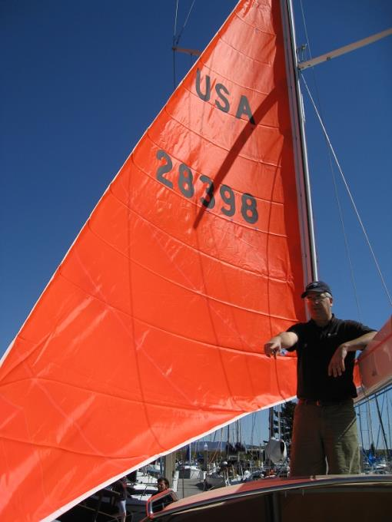
Figure 1 It took a good chunk of the morning for the entire crew of 7 to practice
hoisting the storm sails and figure out the sheeting angles on this Schumacher 52'.

- OSR 4.05.4 Fire Blanket/Fire Plan – The OSR requires “A fire blanket adjacent to every cooking device with an open flame”. The Pacific Cup Equipment List has amended this requirement; instead of requiring a Fire Blanket we require that each boat have a written and documented Fire Plan. This written Fire Plan must be included in your binder of boat documents to be reviewed by your Safety Inspector.

I discussed the subject of Fire Suppression in a previous article, Safety Procedures for PCYC Offshore Academy, but will repeat some key points and include a sample Fire Plan below.

- Preventing fires from starting is the best defense, so with that in mind here is a
rundown of the most common causes of marine fires according to the insurance
claims of Boat U.S.:
1) 55% Poorly installed electrical systems
2) 24% Engine and Transmission Overheating
3) 8% Gasoline fuel leak (95% of fuel-related fires involve gasoline)
4) 7% Miscellaneous (did not fit into a category, but only one could not have
been prevented, cause was lightning)
5) 5% Unknown (boat burned beyond ability to identify cause)
6) 1% Stove (has dramatically lessened with declining use of alcohol stoves)
b. OSR 4.04.2 [Each boat must have] Fire Extinguishers, at least two, of minimum 2kgs (4.4 lbs.) each of dry powder or equivalent. Note the minimum weight; most boats have smaller fire extinguishers which will not meet the requirement.
c. Sample Fire Plan:
Fire Suppression Plan
  - Find the fire, the location, and its size
  - Inform the Skipper and crew immediately
    - Communicate - make distress call to Coast Guard and nearby vessels
  - Restrict the fire
    - If possible, disable cause of fire
      - De-energize electrical systems in affected space/turn off at the source
      - Shut off fuel supply and ventilation
    - Prior to activating extinguishers ensure that all crew have been evacuated from the space
  - Extinguish the fire
    - Account for crew and assess for possible burns or injury
    - Follow-up communication with Coast Guard and other vessels
    - Overhaul (clean and repair) and set re-flash watch
    - If unable to control fire, prepare to abandon ship

- OSR Section 5 - Personal Equipment. Every inflatable PFD must have at least one spare cartridge/arming kit. Seems like a no brainer, doesn’t it? Previously, crew could “share” spare arming kits, but with so many different inflatable PFDs on the market this sharing business no longer makes sense.

Every single person participating in an offshore race or cruise should read the entire Section 5, Personal Equipment. This section discusses the requirements and recommendations for personal safety gear such as Lifejackets (and accessories), and harness and tether requirements.

Our area has experienced some preventable tragedies in the recent past, and if there is one thing we have learned, possibly above all others, is that each crew must take responsibility for having and using, as in wearing, the personal safety gear that is appropriate for their situation.

Other Emergency Gear
In addition to these notable changes to the OSR and Pacific Cup Equipment List, there are some other key pieces of Emergency Gear that always generate a lot of discussion and general gnashing of teeth. Every race year we seem to get a number of questions about Emergency Steering, MOB Gear, Anchoring Tackle, and Liferafts.

Emergency Steering
About 10 years ago, longtime Pacific Cup participant and Safety Inspector Paul Kamen researched the history of rudder failures, and found that since 1980, Pacific Cup races had between a 2% and 3% failure rate of main rudders.

There are different styles of emergency steering and it is up to the responsible skipper to insure the e-steering is compatible with the boat. Will you need an emergency rudder or will another method work? It is generally felt that by far the best solution is to have a constructed emergency rudder stowed on board and ready to deploy. But what type of emergency rudder should you have?

A key consideration is the ability of the crew to be able to deploy the emergency steering. A full crew that includes several bruisers might be able to handle a gudgeon and pintle arrangement, while a double-handed team might be better off using a cassette arrangement. It depends on the boat, the choice of emergency steering, and the crew.
Yachts and/or skippers should be prepared to demonstrate on-the-water functionality of their emergency steering, usually emergency rudder and tiller, both upwind and downwind in true wind of at least 10 knots, to their inspector.

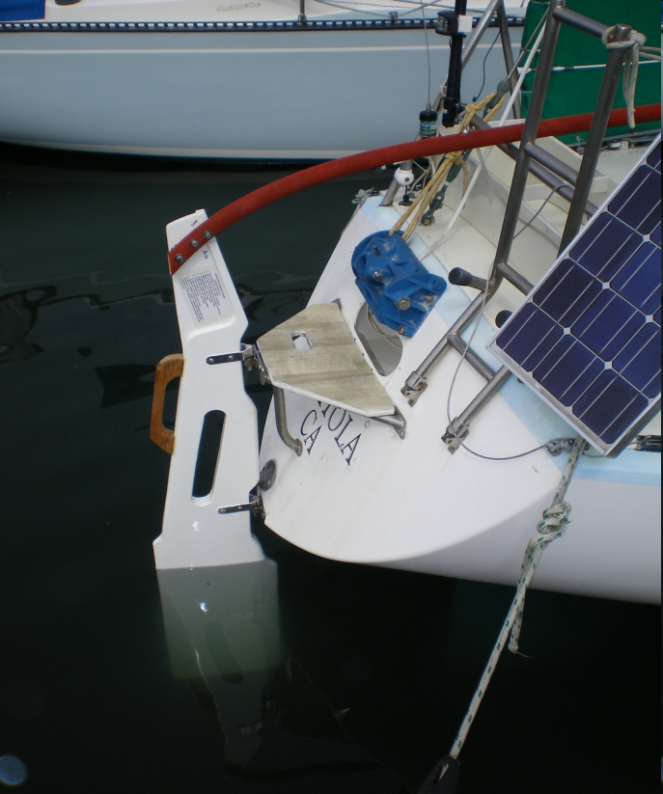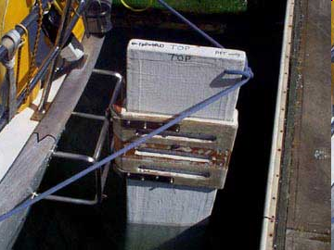
Figure 2 Wylie 27 Gudgeon and Pintle (SSS) Figure 3 Passport 40 Cassette (Pineapple Sails)

While inspecting a boat in 2012 one of our inspectors requested a demonstration of that boat’s emergency rudder. They were unable to coordinate a day, so the skipper agreed to test their emergency rudder on the way home from an ocean race, record the test, and send it to us. They were in about 15 knots of breeze in low to moderate swell, enjoying the success of their design, when suddenly the rudder folded in half. It’s possible this event is still floating around YouTube somewhere. Their revised rudder and re-test was much more successful. The first lesson here is that it can (and usually does) take more than one effort (or two, or three) to figure out an emergency rudder setup that works. The second lesson is that the emergency rudder is only as strong as the weakest link in its construction. In my story of losing a rudder in 1998, we actually broke our emergency rudder due to a weakness in the rudder bracket. The rudder itself was bomb-proof. The bracket, alas, was not. We continued onward, steering with double headsails.

Here are some of my favorite discussions/examples of emergency rudders, and ones that I have gone back to over the years:
- Pacific Cup Knowledge Base: Emergency Steering
- Beth and Evans: Emergency Steering Solutions by Evans Starzinger
- Pineapple Sails: Help with Emergency Rudder Installations
- Singlehanded Sailing Society: Self Steering and Emergency Rudders Seminar by Rob MacFarlane
- Singlehanded Sailing Society: Emergency Rudder Designs

Crew Overboard (MOB/COB) Gear
OSR 4.22 Lifebuoys - The requirement is to have two items of MOB gear, one item which is deployed to mark the location of the victim (pole and flag), and the other which is designed to retrieve the victim (Lifesling). “Pole and flag” generally means either a MOB pole attached to a lifebuoy, such as a horseshoe, or part of a MOM (Man Overboard Module) or Dan Buoy package.

A MOM8, Dan Buoy, or similar lifebuoy is generally preferable to a pole and horseshoe setup because of its easy and expedient deployment. By making most of the required components inflatable, the MOM8, or similar setup, allows a lot of gear to be deployed by pulling a single pin. If you are racing or cruising on a slower boat then a pole and horseshoe might work for you, but if you are on a boat with any sort of speed then a MOM or similar lifebuoy is preferable. Imagine yourself in the water watching your Santa Cruz 50 speeding away downwind while your crew fumbles around the aft pulpit trying to unfasten your MOB pole. If crew goes into the water then seconds count, so select the lifebuoy setup that makes sense for your boat.

A Lifesling is also required for retrieving the victim and hoisting them aboard. You and your crew should carefully review the Lifesling Instruction Manual that comes with your unit and include it in your COB practice. The manuals are typically several pages long which should give you some idea of what is involved in using the gear.

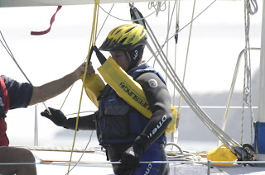
Figure 4 US Sailing, Lifesling Practice - From the 2005 Crew Overboard Symposium on SF Bay
You can review the Lifesling® Owner’s Preparation Guide on the Cruising Club of America’s (CCA) website. There is also a good Lifesling2 Instruction Manual on the West Marine website. Additionally, Sail Magazine has some Sail Gear Review demos on YouTube such as a Lifesling Review and Demo, and MOM8 Review and Demo. Do a search on “Sail Magazine Man Overboard” to find them.

OSR 4.28 Man Overboard Alarm, states that “A yacht shall be equipped with an EPFS (e.g. GPS) capable of immediately recording a man overboard position from each helm station.” Make sure every crew knows how to activate this alarm.
Personal MOB Devices – many yachts and individual crew now include Personal Locater Beacons (PLB) and Personal AIS beacons as part of their personal safety gear. Just make sure your personal beacon is compatible with the boat. In other words, if you use a personal AIS beacon make sure your yacht is AIS-equipped.
Anchoring Tackle (Anchor, chain and line)
Yes, the PCYC considers anchoring tackle to be an essential part of a yacht’s emergency gear. We depart California on a lee shore and arrive in Oahu on a lee shore, and if we ever need to use our anchoring tackle we need to make sure it is 1) robust and adequate enough for the yacht, and 2) easily deployable. Does this mean you have to keep your primary anchor on the bow for the entire race? No, but it does mean that you should be able to easily deploy your anchor(s), especially as you leave California and approach Hawaii.

We provide minimum anchor tackle requirements in the Pacific Cup Equipment List which are outlined in Chart A at the end of the document. In short, each yacht must have:
- Primary anchor tackle
  - One primary anchor that meets the anchor manufacturer’s guidelines for use on a vessel of your size and design
  - Chain that is at least LOA/2 in length, and weight as specified in Chart A
  - At least 200' of nylon line as a single line (not spliced, tied, etc.) with a minimum diameter per Chart A
- If LOA is 28' or greater two anchors are required
  - Secondary anchor may be smaller by no more than one size per the anchor manufacturer’s guideline
  - Secondary chain must be the SAME SIZE AND WEIGHT as primary chain
  - Secondary line may be 150’ with a minimum diameter per Chart A

Skippers are cautioned that these are minimum requirements, and that anchor and rode selection should in every case be adequate for self-rescue and preservation in the event of coastal emergency.

Liferaft
OSR 4.20 - It is the skipper’s responsibility to make sure a yacht’s liferaft meets all sections of the ISAF Offshore Special Regulations on Liferafts. Read these sections carefully to insure that the liferaft you purchase, rent or borrow is compliant, whether it is a SOLAS "A" pack, ISO 9650 Part I Type I Group A, or other.
Certification: Regardless of which type is chosen, the liferaft status /servicing certificate must indicate which standard of approval with which it complies. Some liferaft rental agencies do not automatically include this information on the certification so make sure you specifically request it. This certificate must be included with your boat’s documents and presented to your Safety Inspector prior to your inspection. If you are renting a liferaft and do not have it for your inspection you can usually request the certificate in advance.
A liferaft is a big ticket item and it often makes sense to rent or borrow one if you can. A typical arrangement when borrowing a liferaft is to have it serviced just prior to the race, so you are basically updating it for the owner. However, it is not inexpensive to have a liferaft serviced, so you might want to compare prices of servicing vs. renting one. If you go with borrowing a liferaft just make sure 1) it will be compliant with the current regulations and 2) it is in good enough condition that you don’t end up paying hundreds of dollars more to repair or replace broken bits and pieces.
In addition to liferaft construction and certification requirements there are also regulations regarding liferaft stowage - OSR 4.20.3 Liferaft Packing and Stowage. A liferaft packaged in a rigid container or canister can be stored on deck, in the cockpit, or in a self-draining compartment opening onto the deck. A liferaft packaged in a soft valise, which weighs more than 40kg (88.18 lbs.), can be stored only in a self-draining compartment opening onto the deck. A liferaft packaged in a valise, which weighs less than 40 kg, may be stored below decks on a yacht with a series date before 2001. Regardless of the storage arrangement, it must comply with OSR 4.20.4, Liferaft Launching, which requires that it take no longer than 15 seconds to get the liferaft from its storage position to the rail of the boat.
Crew Responsibility
Even though “The safety of a yacht and her crew is the sole and inescapable responsibility of the person in charge”, recent events have shown us that a seaworthy crew is crew that takes responsibility for their safety instead of relying on the skipper or person in charge to “take care” of them. Just as crew should be responsible for their own safety gear, they should share in the responsibility of knowing how to operate all the emergency and safety gear aboard the boat. In a sense, a well-trained crew is a yacht’s most important safety gear.

A responsible skipper will understand that delegation is key to a successful Pacific Cup program, but that it is important to follow up and take ultimate responsibility for all aspects of the race.

Good crew will understand that the more they know about the yacht’s systems and equipment, the more useful they will be as crew. With knowledge comes enhanced safety, comfort and overall enjoyment.

To help achieve this goal, every yacht must have a Safety Equipment Storage Chart with the location of all safety equipment and thru-hull fittings clearly marked. In addition to this chart, every yacht must have a boat binder that contains certain documentation including the yacht’s Fire Plan and other safety procedures, Liferaft and EPIRB certificates, and a certificate that documents when you and your crew performed your Quick Stop MOB drill and Emergency Steering drill.

It does seem a little ironic that you need to have all this emergency gear that you don’t actually want to use. But if you HAVE to use it, make sure it is appropriately robust for your boat, and make sure you and your crew have practiced and are comfortable using it.

Sylvia has been sailing and racing in the SF Bay and offshore waters for over 20 years. She especially enjoys long passages, so naturally thinks the Pac Cup is an ideal excursion. In December of 2012 she took a break from racing and sailed her boat to Mexico. She spent six months cruising in the Sea of Cortez and now feels the Pac Cup anchoring requirements are exceedingly lenient.

